



UI Document- User Interface Document
BANK IFSC CODE

1. Requirements
This application is used for identifying the bank details by entering IFSC Code.

Product Features
URL: www.bankifsccode.com (Don’t click)
  - Home Page:
Home page should be displayed after entering the URL.
Search By IFSC Code option should be displayed in the Home Page
Note : Lot of other options are there. Just ignore it.
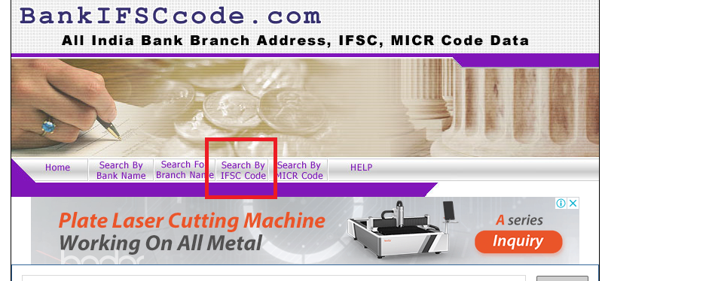
1.2 Search By IFSC Code page
Search By IFSC Code pageshould be displayed when Search By IFSC Code option is clicked from the home page.
This page should contain:
Main Heading: Find Branch Details/Address/MICR Code By IFSC Code
Sub Heading: Enter 11 characters IFSC Code.
Search IFSC Code: Text field should be there.
Search and Reset buttons should be displayed.
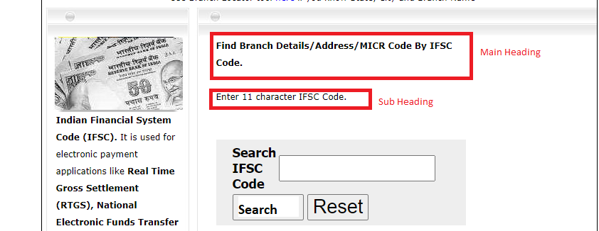
1.3 Search
Search Button: Proper result should be displayed if valid IFSC code is given (SBIN0007617)
“Invalid IFSC Code” message should be displayed if invalid IFSC code is given or no IFSC code is given
Invalid IFSC code = SBIN000761z
1.4 Reset
Reset Button: A message should come “Do you want to clear the entered IFSC code?” with Yes and No options
Entered data should get cleared when click Yes option
Entered data should not get cleared and message should get closed when click No option
1.5 Result:
IFSC Code:- SBIN0007617, STATE BANK OF INDIA, TECHNOPARK, THIRUVANANTHAPURAM
Bank: STATE BANK OF INDIA
Address: TECHNOPARK CAMPUS, KARIAVATTAM,THIRUVANANTHAPURAM, KERALA ,PIN - 695581
State: KERALA
